PROJECT REPORT

ON

SELL JUNK ONLINE

FOR

SUMMER INTERNSHIP 2019

Presented By:

RAHUL KUMAR

Table of Contents

1. Introduction

1.1 Purpose

1.2 Document Conventions

1.3 Intended Audience and Reading Suggestions

1.4 Product Scope

2. Overall Description

2.1 Product Perspective

2.2 Product Functions

2.3 Modules

2.4 Operating Environment

2.5 Design and Implementation Constraints

3. Activity Diagram

4. Output Screen Details

# Introduction

## Purpose

## Document Conventions

Bold-faced text has been used to emphasize section and sub-section headings. Highlighting is to point out words in the glossary and italicized text is used to label and recognize diagrams.

## Intended Audience and Reading Suggestions

This project is a prototype for online selling of junk. This has been implemented under the guidance of my mentor. This project is useful for the government and as well as for the local people.

## Project Scope

In the existing system the user needs to sell their junk when any junk collector comes to their street , the user always have to wait for junk collector to sell their junks so it is a problem for user to wait for long time for selling their junk.

In the proposed system the users and junk collectors are brought to one platform will allow users to be more flexible ,they can register themselves and add request for collecting the junk according to their date and time by selecting time slot and date.

The admin can view the requests and start processing them by allotting a pickup boy according to user date and time slot which they mention in their request.Thus in this way the user can sell their junk online according to their suitable time.

It will be very convenient for the users to add request and sell the junk accordingly. It will save their time as well as energy both and will prove very efficient for them.

# Overall Description

## Product Perspective

An inventory management database system stores the following information.

* **User details:**

The database consists of the username, password, id, gender, email id, mobile no., address,city and state These details provide valid login to user after getting registered.

* **Admin details:**

The DB consists of the username and password. These details provide valid login to admin.

* **PriceList details:**

The DB consists of junk name, id, price and unit. These details provide valid details of junk items.

* **UserPickupRequest details:**

The DB consists of the id, submitted, slot, pickupdate ,address, city, state, status and userid. These details provide valid appointment booking.

## Product Functions

* The user can see the price list of junk , about details and contact details of website.
* The user will register himself / herself on the website by signing up.
* When the user wants to book a pickup request for selling junk online he will login and can select add request option.
* Further he can view his request, cancel request and can edit request.
* Request will be generated and your junk will be collected according to your selected time.

## ****Modules****

This Java project consists of 3 major modules

**Admin**

* Admin Login with Username & Password
* Can add price list
* Can change the status of request
* View All Request
* View price list of junk
* Logout

**User**

* Register
* Login
* Add request for junk collection
* View total requests and total sell requests
* Can edit/view/cancel request
* View his/her profile
* View about and contact details of website
* Logout

## Operating Environment

Operating environment for the inventory management system is as listed below.

* JAVA (Servlets, JSP)
* Eclipse
* JDK 1.7
* MySQL Workbench
* HTML
* JavaScript and CSS
* Apache Tomcat Server

## Design and Implementation Constraints

* SQL commands for above queries/applications
* Implement the DB at least using a centralized DBMS.

Activity Diagram

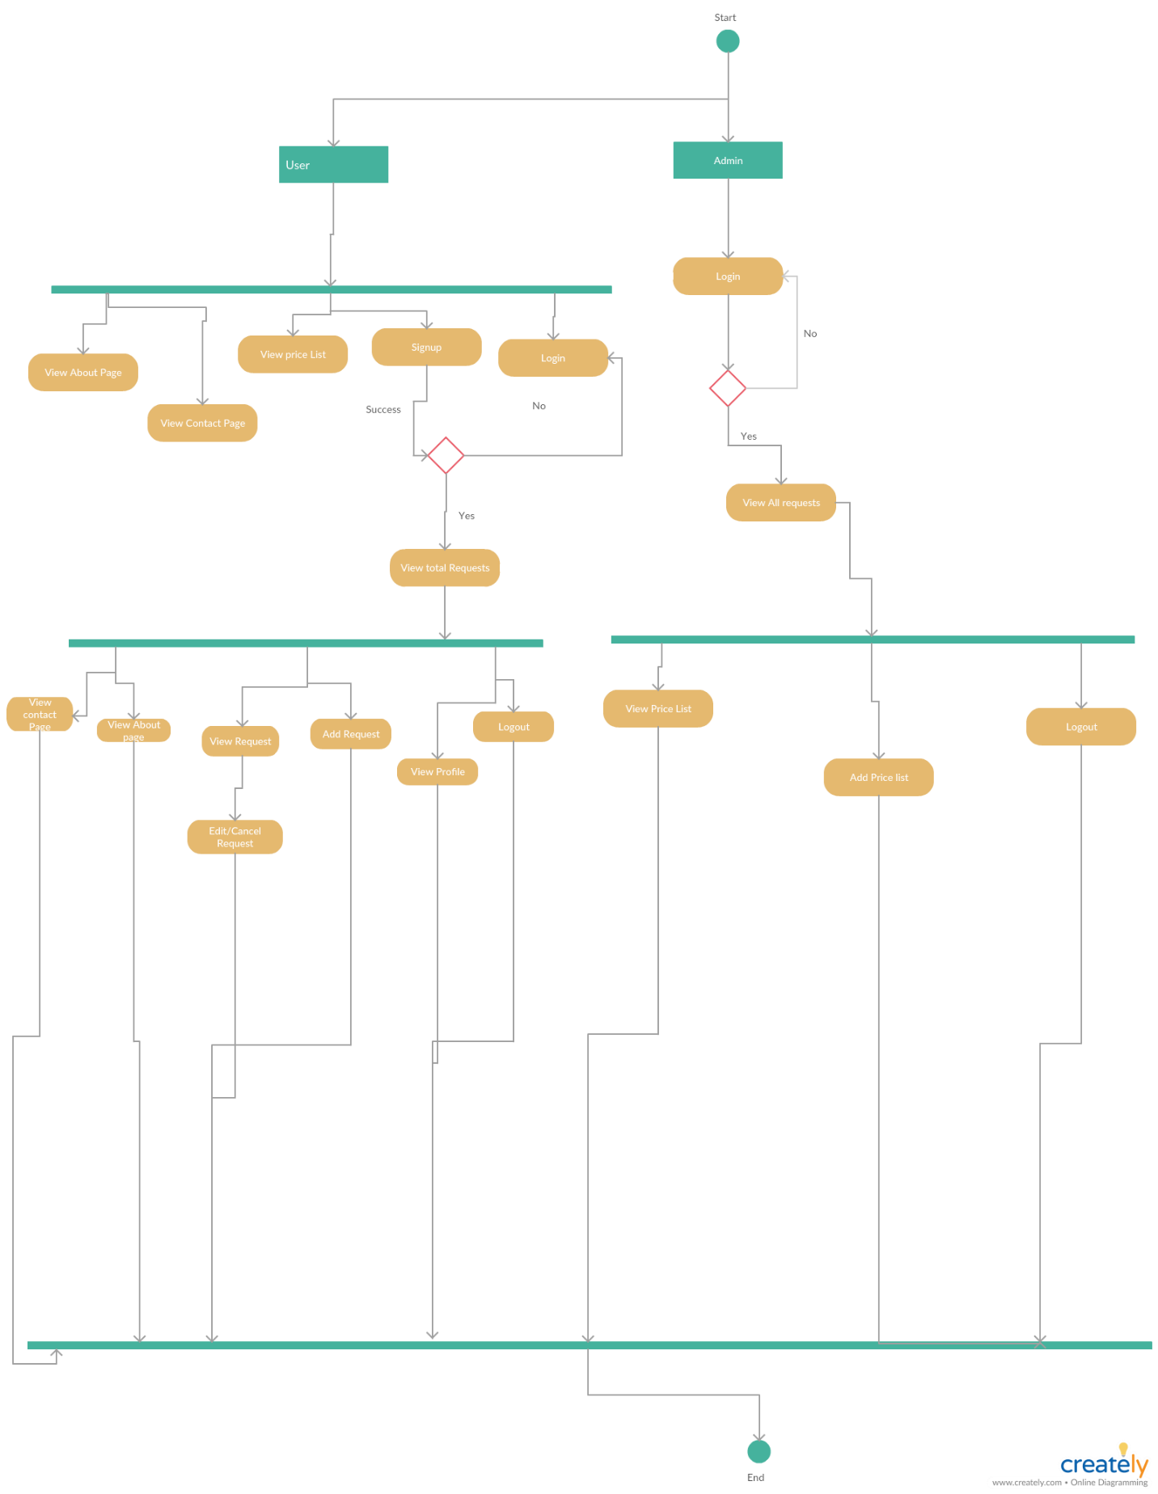

Figure 1 Activity Diagram for sell junk online

**OUTPUT SCREEN DETAILS**

**Welcome page/Sign-In page :**

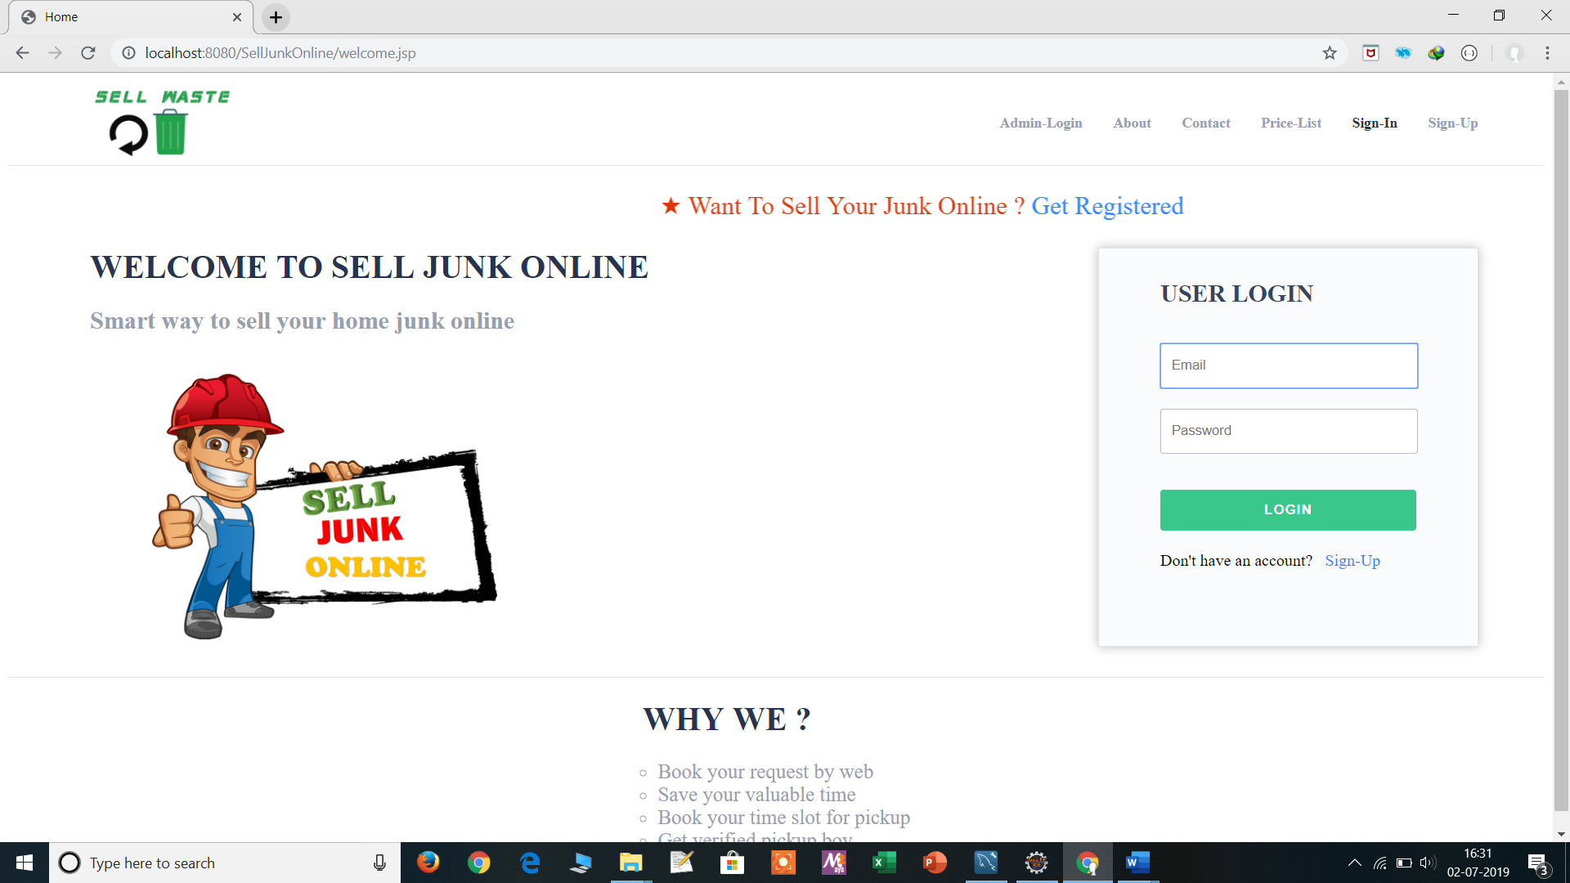

**Admin Login Page :**

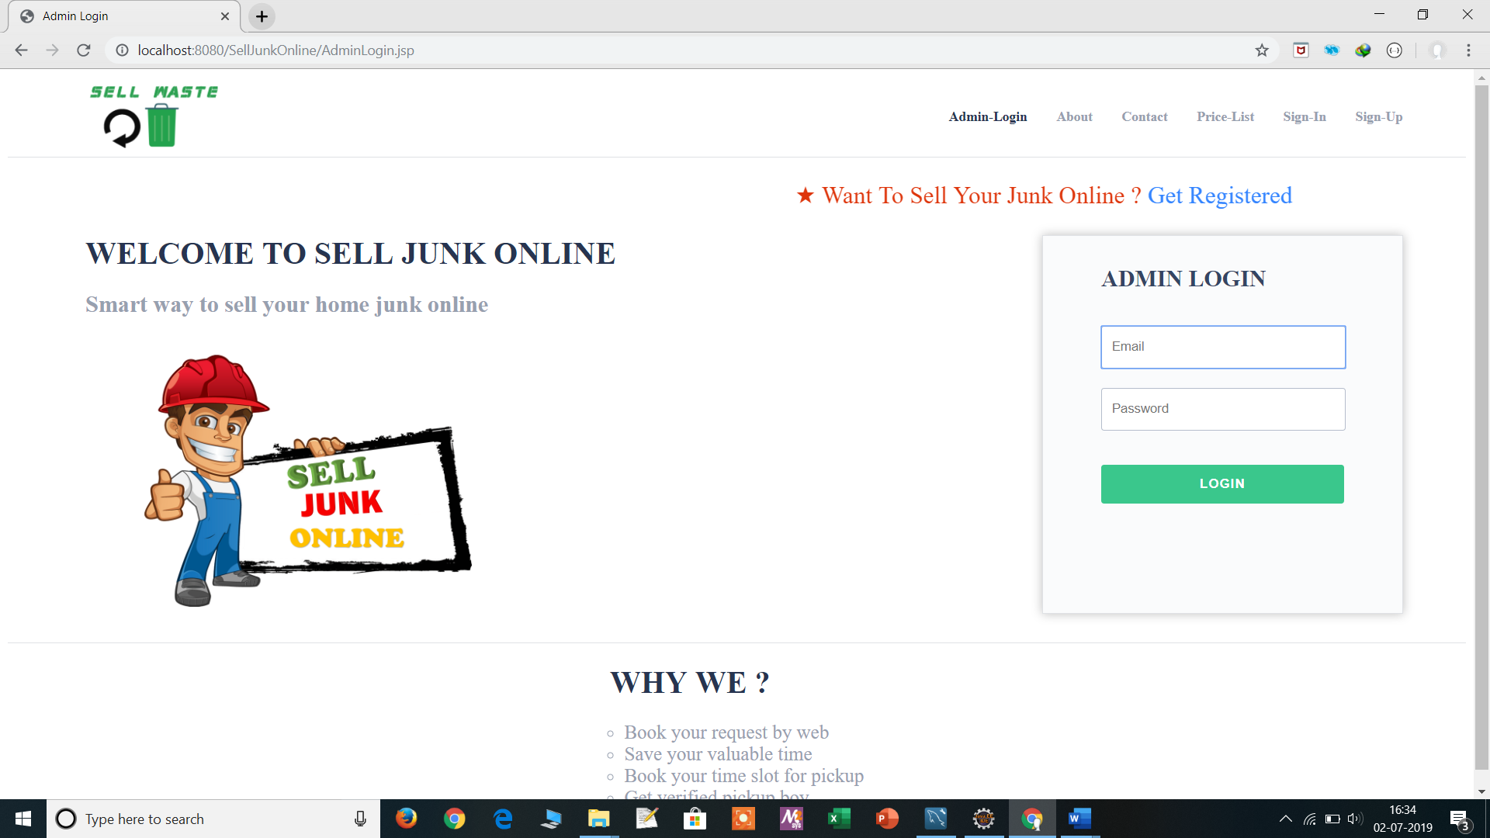

**About Page :**

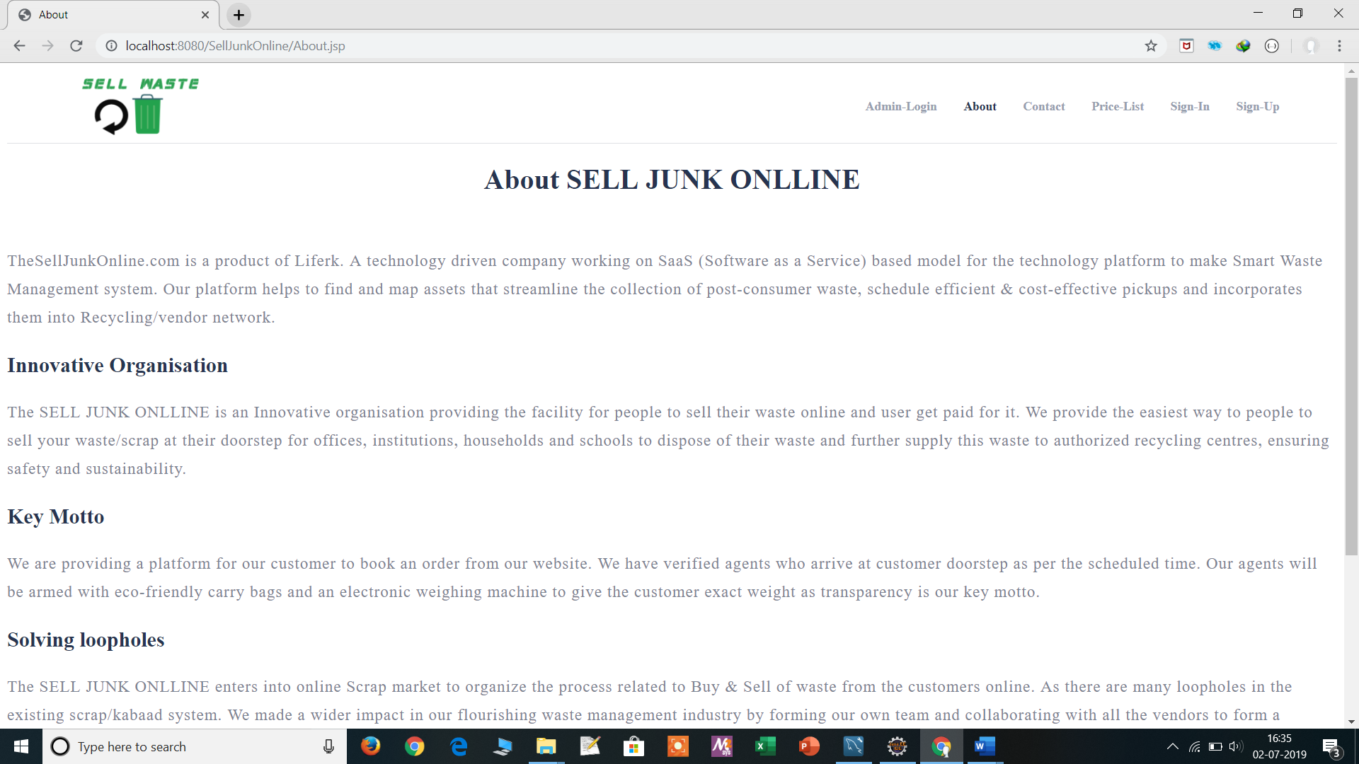

**Contact Page :**

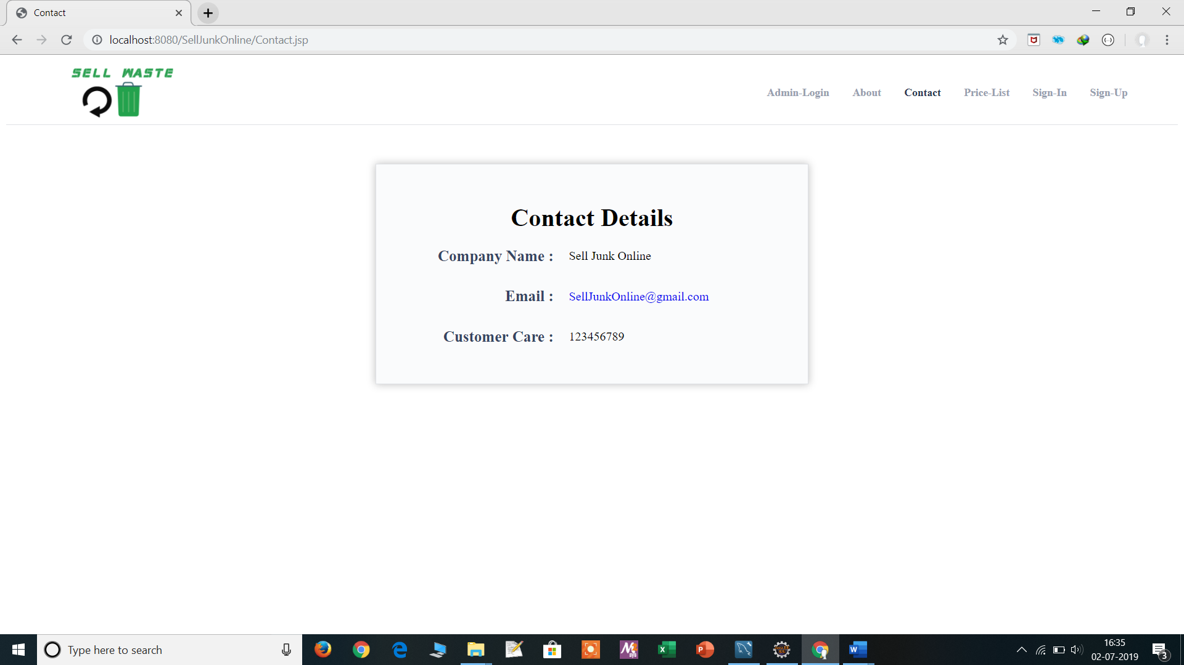

**Price List Page :**

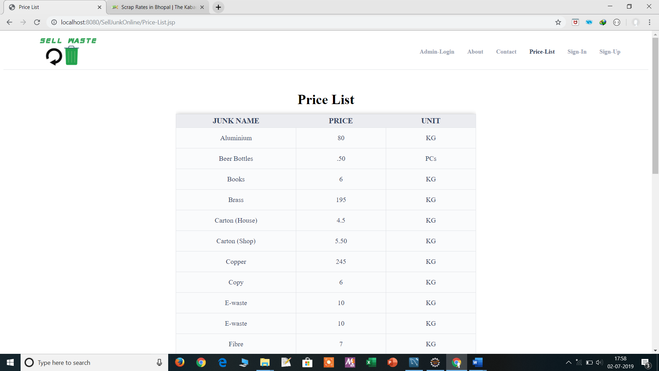

**Sign-Up Page :**

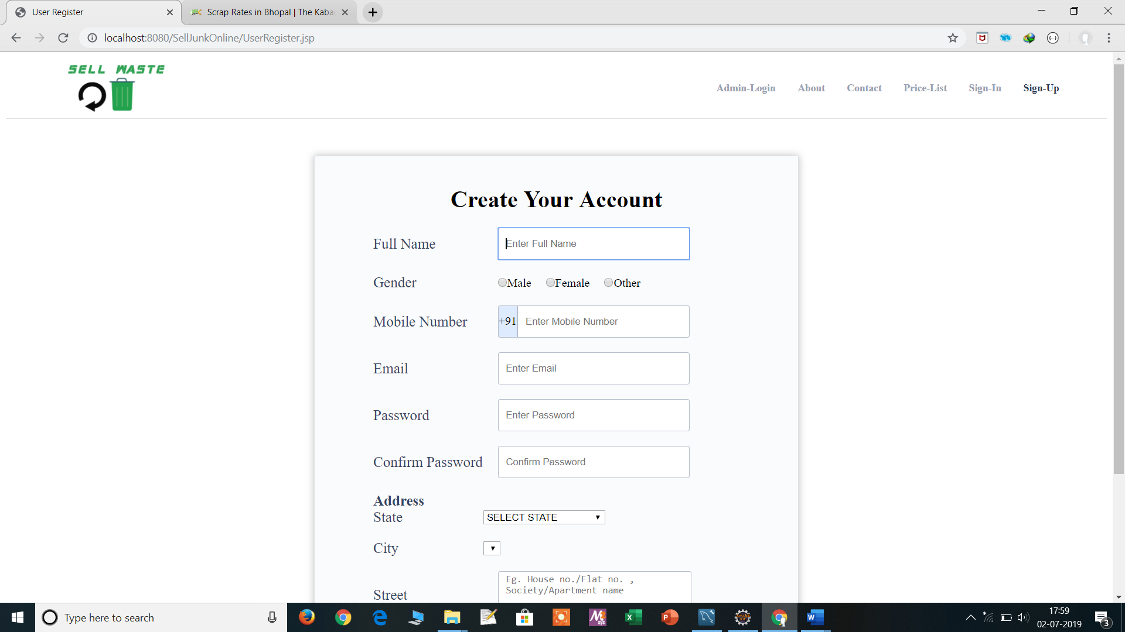

**User View Requests Page :**

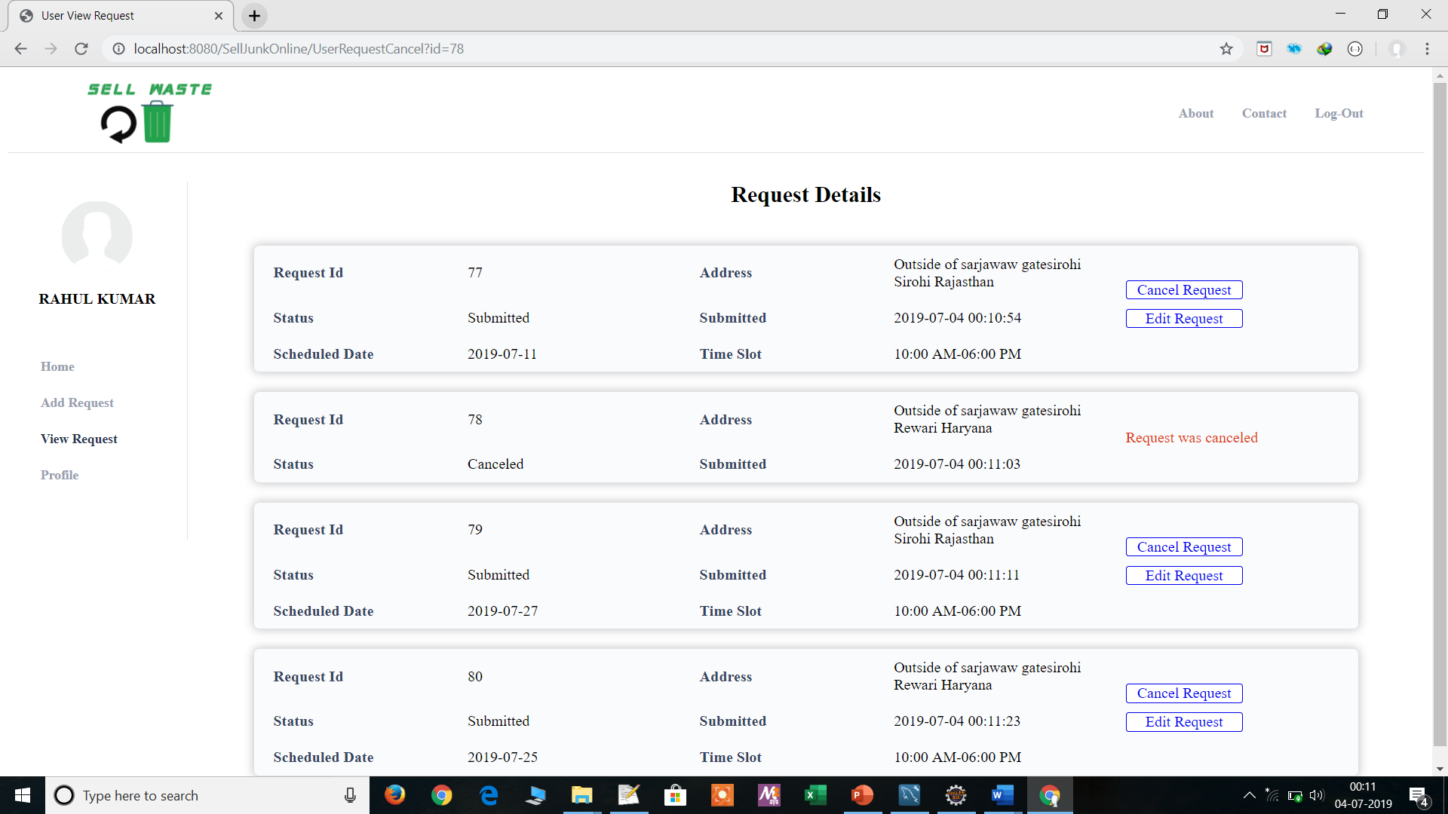

**User Profile Page :**

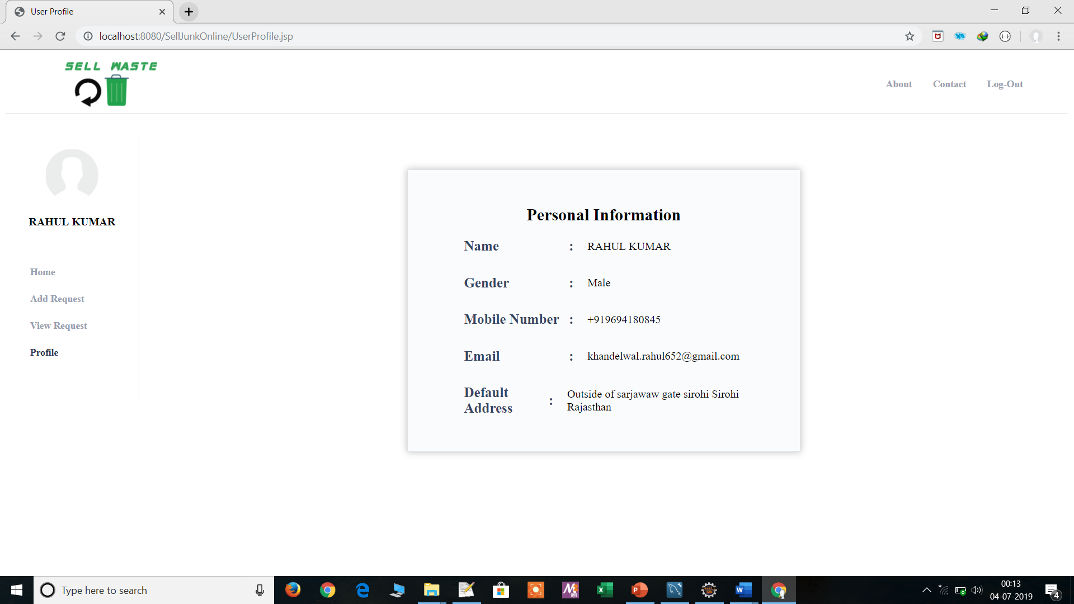

**User Add Request Page :**

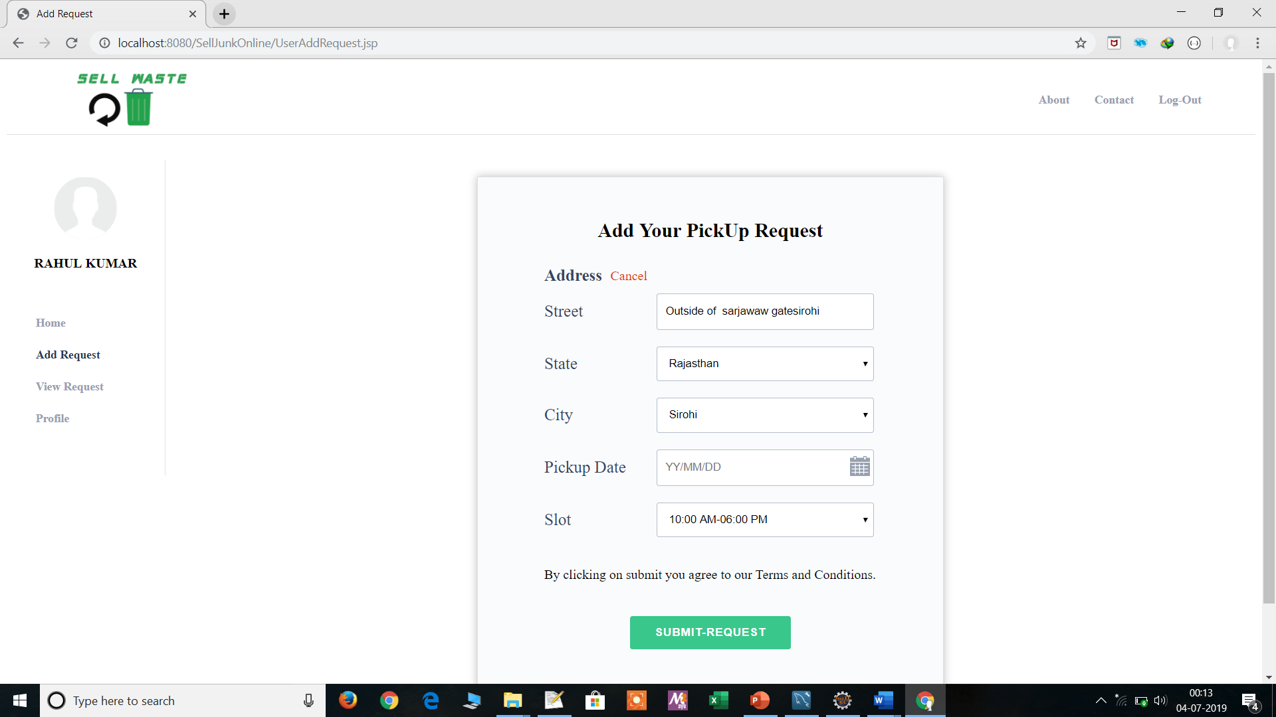

**User Home Page :**

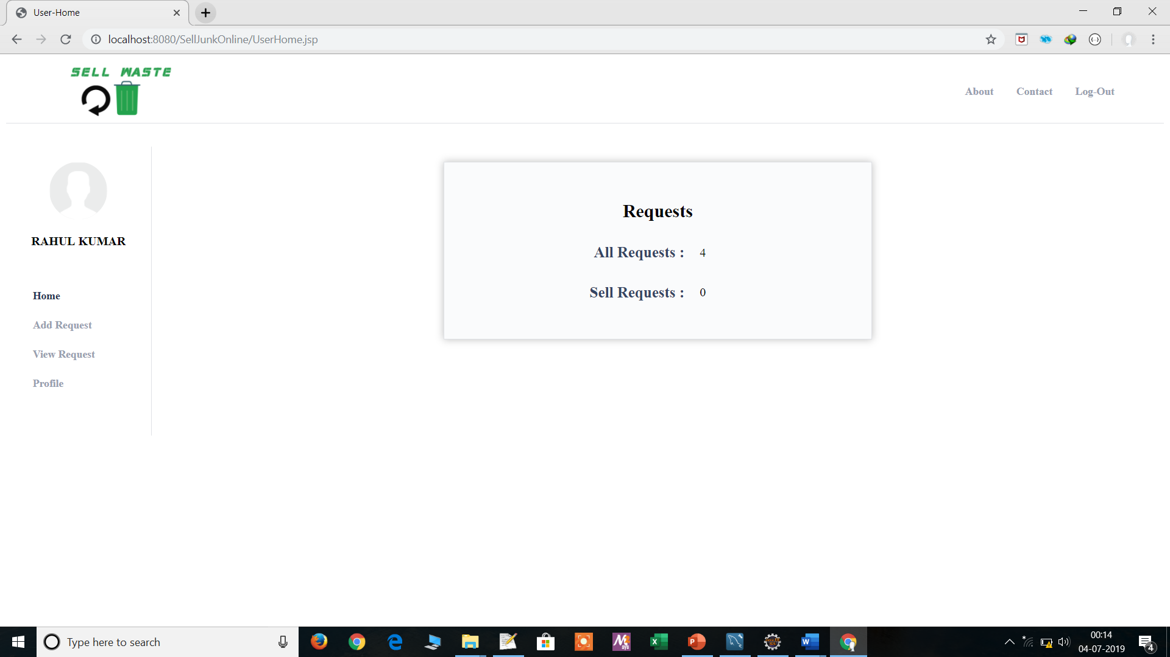

**Admin View-All Requests Page :**

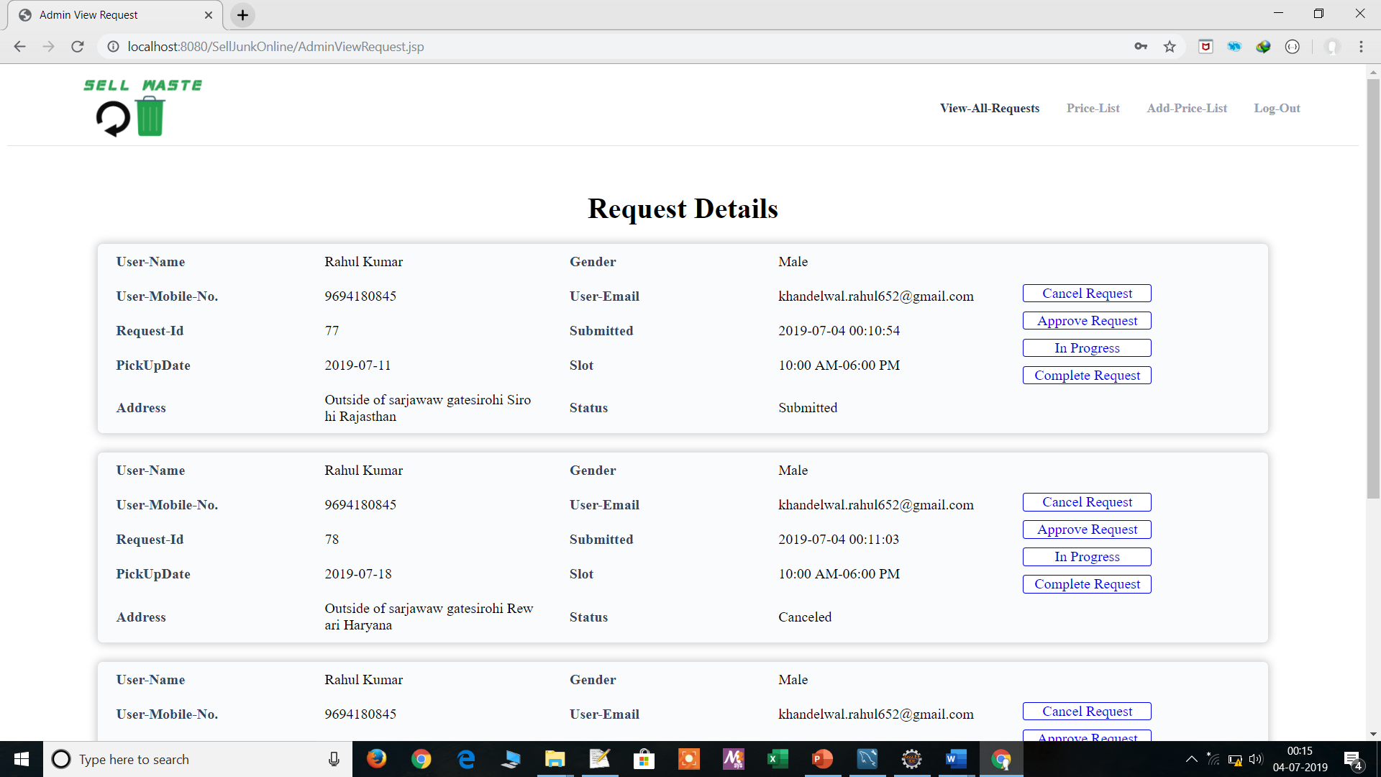

**Admin Add Price-List Page :**

